Spring Core – Load Country from Spring Configuration XML
Created coutry.xml file
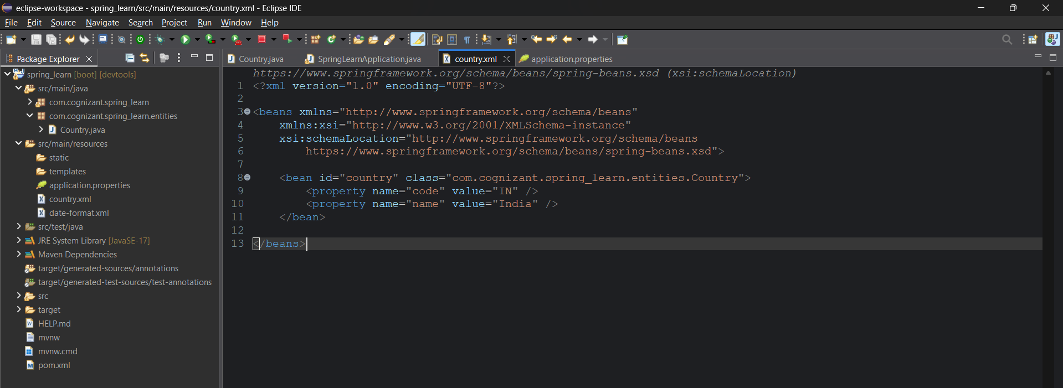
Created a Country class in the entities package with the appropriate logger messages in the setter and getter methods and constructor as well.
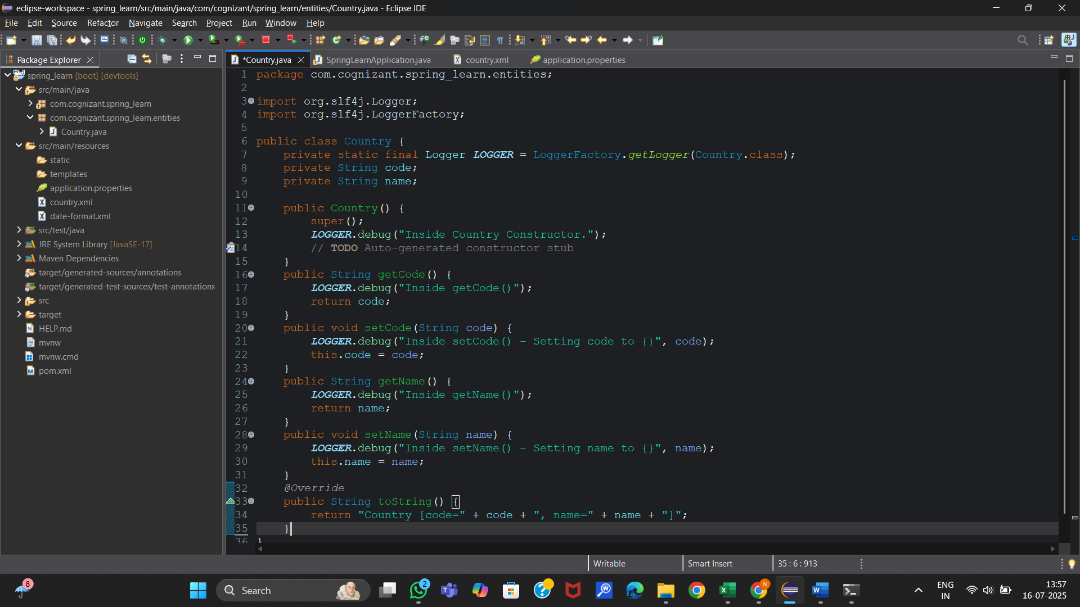
Added displayCountry() method in the main file
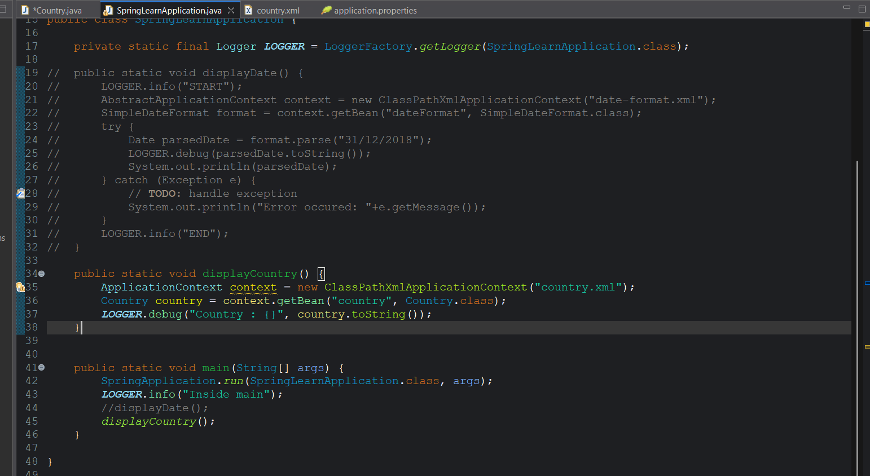
Output:
